Database System Engineering and Distributed Backend Development
Course Code: 25CS1302E
BANK DATABASE – TRIGGERS AND STORED PROCEDURES
Name: V. Charishma
Roll no: 2520030140
Query 1:
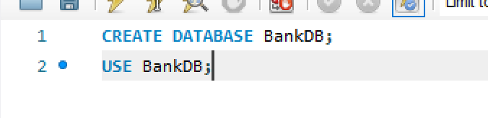
Output:

Query 2:

Output:
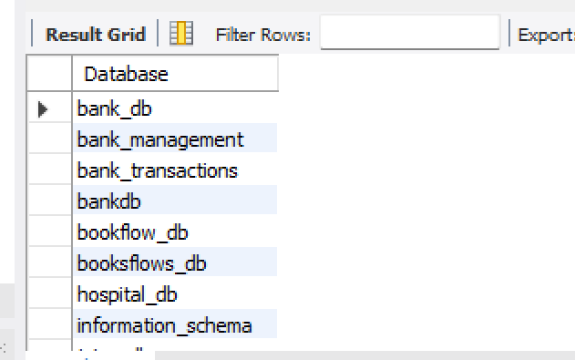
Query 3:

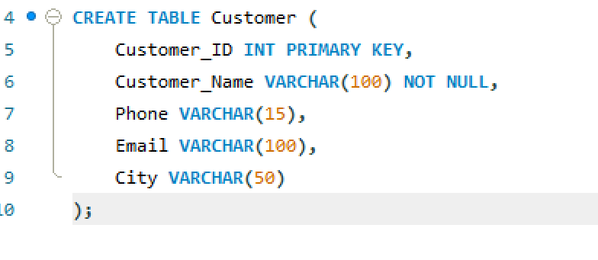
Output:
Query 4:
Output:
